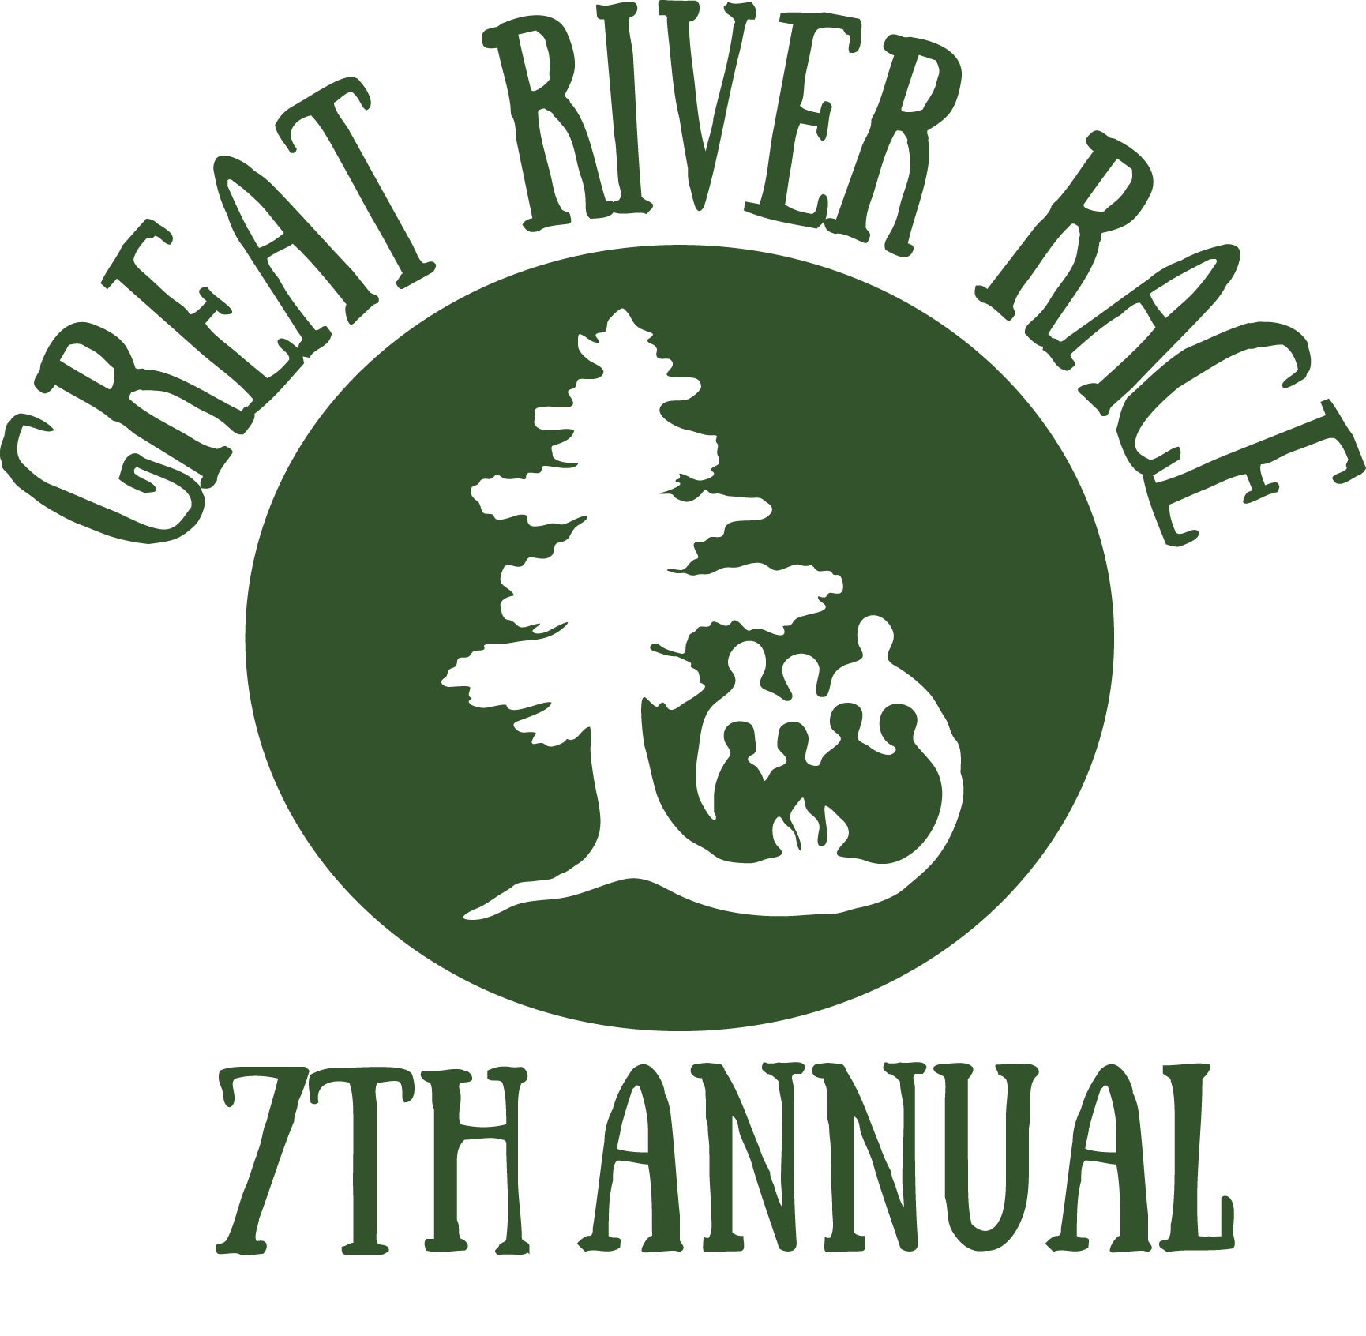
Personal Packing List for the Great River Race
To ensure safety and comfort on race day, we recommend that you wear/bring the following clothing and gear:
Clothing, Outerwear, and Gear
__ T-shirt, ideally in a quick-dry fabric such as poly-propylene or nylon
Note: We encourage teams to coordinate colors and to show your team spirit! Costumes are welcome too. Judges will be watching and selecting a team to receive the Spirit Award.
__ Shorts or zip-off pants, ideally in a quick-dry fabric such as poly-propylene or nylon
__ Jacket or sweater
__ Shoes that you can get a little wet and dirty. You may want to also wear wool socks (Smartwool works great), to keep your feet toasty even if they get wet.
__ Rain jacket or poncho
__ Baseball cap or other brimmed hat to protect you from sun and rain
__ Water bottle
Optional Items
__ Sunscreen / lipbalm
__ Sunglasses
__ Camera
__ Small daypack for personal items
Note: Paddles and life jackets will be provided for all racers. You can bring your own life jacket if you prefer, but you must use a Wilderness Inquiry paddle during the race.
Note: Each boat will have one dry bag for personal items. It is recommended, however, that you protect cameras, wallets, phones, etc., by storing them in Ziploc plastic bags.

